Trinity Christian Reformed Church
3000 East 16th Ave., Anchorage, AK 99508
Office phone: 907-272-8431 E-mail: office@trinitycrcalaska.com
Pastor Bill Vis phone: 907-279-0278 Cell: 907-575-0514
E-mail: billvis1@gmail.com On the Web: www.trinitycrcalaska.com
WORSHIP SERVICE
December 17, 2017 - 11:00 a.m.
APPROACHING TO WORSHIP
Instrumental Prelude: Jan Veltkamp
Welcome and Announcements
* Songs of Praise: “Good Christian Friends, Rejoice” Red #98:1-3
“Joyful, Joyful, We Adore Thee” Red #581:1-3
Lighting of the Advent Wreath (Joy Candle) Simbre Family
Quartet and Congregation: “How Great Our Joy” Red #90
Opening Prayer (in unison)
“Joy to the World” Red #92:1-3
MISSIONARY REPORT
Fort Yukon Report from Cheyenne Norberg
SERVICE OF PRAYER
Prayer Concerns and Congregational Prayer
SERVICE OF THE WORD
* Song of Preparation: “Infant Holy, Infant Lowly” Gray #353:1-2
(Children ages 2-Grade 3 may go upstairs to Children’s Church)
Scripture: Luke 2:1-20 Pew Bible Page(s): 1560-1561
Message: Those Celebrating Angels
Prayer of Application
WITHDRAWING TO SERVE
Morning Offering: Church Ministries, as we sing:
Song of Response: “Jesus, the Light of the World” Red #100:1-4
* God's Blessing
* Doxology: “Go, Tell It on the Mountain” Red #93:1-3
Postlude
* If you are able, please stand
Songs printed and/or projected with permission by CCLI #293603

December 14, 2017

- A review of the November finance report showed November income of $16,774 and expenses of $12,959. Total 2017 income was $182,825 and expenses were $184,682. Thank you for your faithful support of the ministries of the church.
- The Thanksgiving offering for the Anchorage Rescue Mission was $621.
- A thank you letter was received from New Life Church in Houston for gifts received through Classis Rocky Mountain following Hurricane Harvey. Twenty churches gave a total of $13,876. Trinity Church gave $5,366 of that! What incredibly generous people you are! Thank you.
- Jan Henning offered to prepare the communion elements each month. Council enthusiastically and gratefully accepted her offer. Thanks, Jan.
- Council approved a Transition/Welcome Committee of three people for Pastor Ben Hulst and his family. Their mandate is to encourage, guide and inform the Hulst family. Jasper Hall will serve as the council representative and others will be asked to serve.
Announcements
Cheyenne Norberg will speak to the congregation this morning. The 5th Sunday offering on December 31 will go to support Cheyenne’s ministry. Checks should be made payable to the church with Cheyenne’s name on the memo line. All undesignated gifts will go to this ministry.


Christmas Eve Service will be at 7:00.

The Deacons want to remind the congregation that contributions need to be received by Sunday 12/31/2017 to be included in 2017.


Sacred Concert: Next Sunday The Incarnation Will be airing from 6-9 a.m. on KLEF 98.1 FM
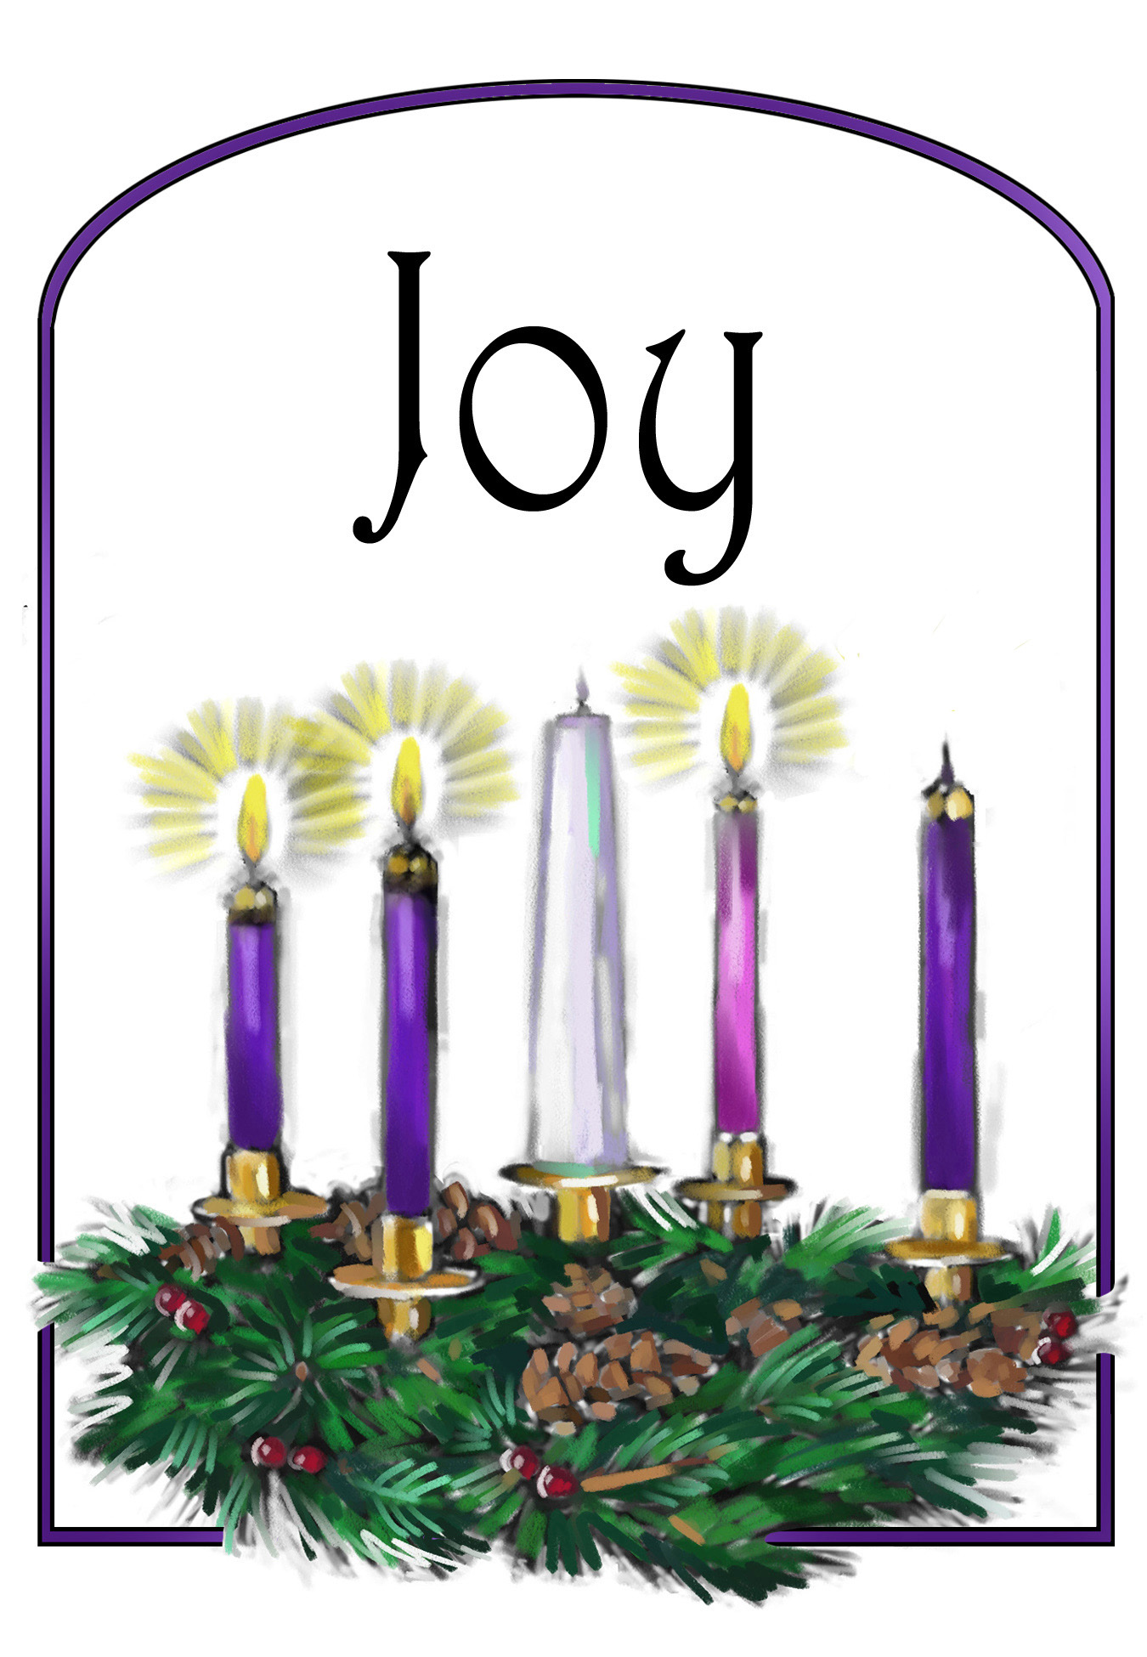

This Week at Trinity

Sunday | 11:00 a.m. | Worship Service
 | 6:30 p.m. | Prayer Service
Tuesday | 7:00 p.m. | Coffee Break
Wednesday | 9:30 a.m. | Coffee Break / Story Hour
Next Sunday | 9:30 a.m. | Sunday School
 | This Week | Next Week
Greeters: | Gayle Cederberg | Gayle Cederberg
Nursery: | Erin Vander Lugt & Kristine Adams | Rose Kuiper & Megan DeVries
Children’s church: | Phyllis Bowman | Kate Hopewell
Coffee Clean-Up
Accompanist: | Jan Veltkamp | Kristi Kleaver & Jan De Yong
Sound:
Offerings: | Church Offerings | Church Offerings
Prayer Service | Veltkamps | No Service

Committees and programs  Contact people  Building & Grounds Bob Groeneweg  Church Admin Assistant Brett Kuiper  Coffee Break Joy Sharpe  Outreach/Missions Gayle Cederberg  Fellowship Ron & Jan Veltkamp  Intercession Jon Sharpe  Library Mandi Dykstra  Prayer Network Pastor Bill  Sunday School Sup’t Kristine Adams  Women's Fellowship Denise Hopewell  Worship Committee Joy Sharpe  Trinity CRC Council: | Church Meeting Schedule  Sunday  Sunday School (Sept. - May) 9:30 a.m.  Morning Worship 11:00 a.m.  Evening Prayer Service 6:30 p.m.  Tuesday (Sept - April)  Coffee Break 7:00 p.m.  Council (2nd Thurs. of month) 7:00 p.m.  Wednesday (Sept-April)  Coffee Break/Story Hour 9:30 a.m.  Thursday  AWANA (Sept- Nov. Jan.-Mar.) 6:15 p.m.  Church Office and Pastor's Hours:  9 a.m. - 12 p.m. Tues. through Thurs.
  Elders  Jasper Hall ‘18  Keith Van Dyken ‘19  Ron Veltkamp ‘20 | Deacons:  Terry Dykstra ‘18  Dave Hopewell ‘19  Jan DeYong ‘20

December 17, 2017


