Trinity Christian Reformed Church
3000 East 16th Ave., Anchorage, AK 99508
Office phone: 907-272-8431 E-mail: office@trinitycrcalaska.com
Pastor Bill Vis phone: 907-279-0278 Cell: 907-575-0514
E-mail: billvis1@gmail.com On the Web: www.trinitycrcalaska.com
WORSHIP SERVICE – November 12, 2017 - 11:00 a.m.
APPROACHING TO WORSHIP
Instrumental Prelude: Jan De Yong
Welcome and Announcements
* Songs of Praise: “God Is Here” Red #246:1,4
* Opening Prayer
“Spirit of the Living God” Red #749:1-2
DECLARING OUR FAITH
I believe in God, the Father almighty,
creator of heaven and earth
I believe in Jesus Christ, his only Son, our Lord,
who was conceived by the Holy Spirit
and born of the virgin Mary.
He suffered under Pontius Pilate,
was crucified, died, and was buried;
he descended to hell.
The third day he rose again from the dead.
He ascended to heaven
and is seated at the right hand of God the Father almighty.
From there he will come to judge the living and the dead.
I believe in the Holy Spirit,
the holy catholic* church,
the communion of saints,
the forgiveness of sins,
the resurrection of the body,
and the life everlasting. Amen.
( * that is, the true Christian church of all times and all places)
Song of Response: “One People, Here, We Gather” Red #243:1,4
Installation Deacon Jan DeYong
Song of Response: “May the Lord God Hear You Pray” Red #894:1-3
SERVICE OF PRAYER
Prayer Concerns and Congregational Prayer
SERVICE OF THE WORD
* Song of Preparation: “The Servant Song” Red #309:1-5
(Children ages 2-Grade 3 may go upstairs to Children’s Church)
Scripture: Numbers 11:4-34 Pew Bible Page(s): 204-205
Message: Forget About It!
Prayer of Application
WITHDRAWING TO SERVE
Morning Offering: Church Ministries, as we sing:
Song of Response: “Lord of All Good” Red #879:1-3
* God's Blessing
* Doxology: “In Our Lives, Lord, Be Glorified” Red #861:1,3,4
Postlude
* If you are able, please stand
Songs printed and/or projected with permission by CCLI #293603

November 2017

- A review of the October finance report showed October income of $19,019 and expenses of $15,927. Total 2017 income was $165,985 and expenses were $170,930. Thank you for your faithful support of the ministries of the church.
- The Fifth Sunday offering for the Downtown Soup Kitchen was $1,160.
- Officers for the new council were appointed as follows: president – Pastor Bill; vice-president – Jasper Hall; clerk – Keith Van Dyken; treasurer – Dave Hopewell; chair of the deacons – Terry Dykstra.
- Jan De Yong will be installed today. Ron Veltkamp will be installed on December 10.
- The normal meeting date for council will be on the second Thursday of each month. The next meeting will be on Thursday, December 14.
- A nativity display will be presented the weekend of December 3. The church will purchase advertising in the Alaska Dispatch News inviting the public to this and all Advent worship services, including the Christmas Eve Service of Lessons and Carols.
- Initial discussion was held regarding the formation of a Transition / Welcome Committee for the Hulst family. This will be finalized next month.
This Week at Trinity

Sunday | 11:00 a.m. | Worship Service
 | 6:30 p.m. | Prayer Service
Tuesday | 7:00 p.m. | Coffee Break
Wednesday | 9:30 a.m. | Coffee Break / Story Hour
Thursday | 6:15 p.m. | AWANA
Next Sunday | 9:30 a.m. | Sunday School
 | This Week | Next Week
Greeters: | D & D Hopewell | D & D Hopewell
Nursery: | Charlotte & Mark Long | Jan Henning & Charlie Beltran
Children’s church: | Phyllis Bowman | Kate Hopewell
Coffee Clean-Up
Accompanist: | Jan DeYong | Kristi Kleaver
Sound: |  | Dave Hopewell
Offerings: | Church Offerings | Church Offerings
Church Family

Megan DeVries will be singing in the choir at the All State Music Festival on November 18th 6:00 PM at West High School. All are welcome to attend.

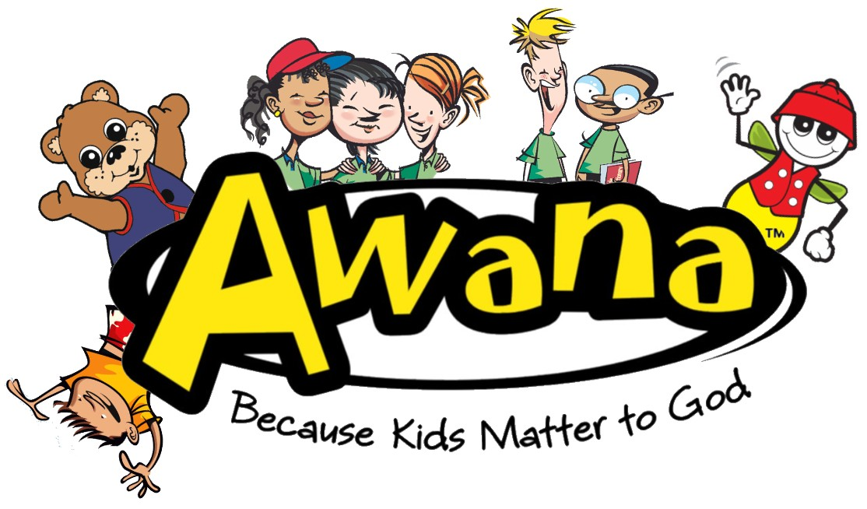
Announcements

This Thursday is the last day for AWANA until January.

We will be hosting a joint community Thanksgiving Day service Thursday morning, November 23, at 10:00 a.m. involving three congregations. Offering will be for the Anchorage Rescue Mission. Please join us as we give thanks to our God. Invitations for family, friends and neighbors are in the lobby. You many also invite people using the event, on the church’s Facebook Page.

Thanksgiving Blessing: Every Thanksgiving the Anchorage communities come together through the leadership of the Food Bank of Alaska to make sure that families in need can celebrate the holiday with a complete Thanksgiving meal. Trinity will collect canned corn. The Seventh Day Adventist Church will be joining in this effort. Trinity can make a real difference—let’s joyfully share with our neighbors this Thanksgiving!

The Outreach Committee is collecting warm clothing and other winter gear in conjunction with the Thanksgiving Day offering, which will support the Alaska Rescue Mission. The mission, in their last newsletter, has noted a need for children items as well as adults. Boxes will be placed at the back of the sanctuary to accept donation. Please bring all donations by the Sunday after Thanksgiving.
Sacred Concert: Next Sunday We Thank You, Lord, We Thank You! Will be airing from 6-9 a.m. on KLEF 98.1 FM
Committees and programs  Contact people  Building & Grounds Bob Groeneweg  Church Admin Assistant Kate Hopewell  Coffee Break Joy Sharpe  Outreach/Missions Gayle Cederberg  Fellowship Ron & Jan Veltkamp  Intercession Jon Sharpe  Library Mandi Dykstra  Prayer Network Pastor Bill  Sunday School Sup’t Kristine Adams  Women's Fellowship Denise Hopewell  Worship Committee Joy Sharpe  Trinity CRC Council: | Church Meeting Schedule  Sunday  Sunday School (Sept. - May) 9:30 a.m.  Morning Worship 11:00 a.m.  Evening Prayer Service 6:30 p.m.  Tuesday (Sept - April)  Coffee Break 7:00 p.m.  Council (2nd Thurs. of month) 7:00 p.m.  Wednesday (Sept-April)  Coffee Break/Story Hour 9:30 a.m.  Thursday  AWANA (Sept- March) 6:15 p.m.  Church Office and Pastor's Hours:  9 a.m. - 12 p.m. Tues. through Thurs.
  Elders  Jasper Hall ‘18  Keith Van Dyken ‘19  Ron Veltkamp ‘20 | Deacons:  Terry Dykstra ‘18  Dave Hopewell ‘19  Jan DeYong ‘20
November 12, 2017

