Trinity Christian Reformed Church
3000 East 16th Ave., Anchorage, AK 99508
Office phone: 907-272-8431 E-mail: office@trinitycrcalaska.com
Pastor Bill Vis phone: 907-279-0278 Cell: 907-575-0514
E-mail: billvis1@gmail.com On the Web: www.trinitycrcalaska.com
WORSHIP SERVICE
October 29, 2017 - 11:00 a.m.
APPROACHING TO WORSHIP
Instrumental Prelude: Jan De Yong
Welcome and Announcements
* Opening Song: “A Mighty Fortress Is Our God” Red #776:1-4
* Sola Gratia (by grace alone)
Q. Why can’t our good works be our righteousness before God, or at least a part of our righteousness?
A. Because the righteousness which can pass God’s judgment must be entirely perfect and must in every way measure up to the divine law.
But even our best works in this life are imperfect and stained with sin.
Q. How can our good works be said to merit nothing when God promises to reward them
in this life and the next?
A. This reward is not earned; it is a gift of grace.
“By Grace We Have Been Saved” Red #675:1-3
Sola Fide (through faith alone)
Q. What is true faith?
A. True faith is not only a sure knowledge by which I hold as true all that God has revealed to us in Scripture; it is also a wholehearted trust, which the Holy Spirit creates in me by the gospel, that God has freely granted, not only to others but to me also, forgiveness of sins, eternal righteousness, and salvation.
These are gifts of sheer grace, granted solely by Christ’s merit.
“Faith Begins by Letting Go” Red #852:1-3
* Opening Prayer
Solus Christus (in Christ alone)
Q. Why must the mediator be a true and righteous human?
A. God’s justice demands that human nature, which has sinned, must pay for sin;
but a sinful human could never pay for others.
Q. Why must the mediator also be true God?
A. So that the mediator, by the power of his divinity, might bear the weight of God’s wrath in his humanity and earn for us and restore to us righteousness and life.
Q. Then who is this mediator—true God and at the same time a true and righteous human?
A. Our Lord Jesus Christ, who was given to us to completely deliver us and make us right with God.
“In Christ Alone” Red #770:1-4
SERVICE OF PRAYER
Prayer Concerns and Congregational Prayer
SERVICE OF THE WORD
* Song of Preparation: “Ancient Words” Red #762:1
Sola Scriptura (Scripture Alone)
Belgic Confession Article 7 – The Sufficiency of Scripture
We believe that this Holy Scripture contains the will of God completely and that everything one must believe to be saved is sufficiently taught in it.
For since the entire manner of service which God requires of us is described in it at great length, no one — even an apostle or an angel from heaven, as Paul says — ought to teach other than what the Holy Scriptures have already taught us.
“Ancient Words” Red #762:2
(Children ages 2-Grade 3 may go upstairs to Children’s Church)
Scripture: Acts 4:1-21 Pew Bible Page(s): 1660-1661
Message: A Courageous Attitude
Prayer of Application
WITHDRAWING TO SERVE
Morning Offering and Offertory: Downtown Soup Kitchen
* Songs of Response:
Soli Deo Gloria (to the glory of God alone)
Belgic Confession Article 23 – The Justification of Sinners
We believe that our blessedness lies in the forgiveness of our sins because of Jesus Christ, and that in it our righteousness before God is contained, as David and Paul teach us when they declare those people blessed to whom God grants righteousness apart from works.
And the same apostle says that we are “justified by his grace as a gift, through the redemption that is in Christ Jesus.” And therefore we cling to this foundation, which is firm forever, giving all glory to God, humbling ourselves, and recognizing ourselves as we are; not claiming a thing for ourselves or our merits and leaning and resting on the sole obedience of Christ crucified, which is ours when we believe in him.
“I Will Exalt” Red #37:1-2
“All Glory Be to God on High” Red #542:1
“To God Be the Glory” Red #956
* God's Blessing
* Doxology: “Praise God from Whom All Blessings Flow” Red #965
Postlude
* If you are able, please stand
Songs printed and/or projected with permission by CCLI #293603

Announcements

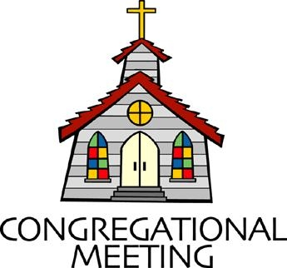
The congregational meeting to vote on those qualified to hold office and to review the proposed budget will be held after the morning service today. Nominated for Elder; Ron Veltkamp, Mike Lindeen and for Deacon; Jan De Yong, Brett Kuiper, and Charlotte Long. The casting of the lot for elder and deacon will take place after the morning service next week.

Copies of the proposed budget have been placed in the folders. Please review before the congregational meeting today.

Today’s offering will be for the Downtown Soup Kitchen.
All undesignated gifts will go to this ministry.

There will be a luncheon next Sunday after the service.
Please bring your favorite dish to share.

Daylight Saving Time ends next Sunday,
so be sure to set you clocks back an hour.

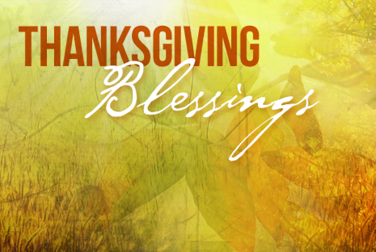
Thanksgiving Blessing: Every Thanksgiving the Anchorage communities come together through the leadership of the Food Bank of Alaska to make sure that families in need can celebrate the holiday with a complete Thanksgiving meal. Churches play an important role in gathering a lot of the ingredients and helping families through the process on distribution day. They are expecting 3000+ participants this year. CAN YOU HELP? Let’s create a huge pyramid of canned corn! Trinity will collect canned corn. The Seventh Day Adventist Church will be joining in this effort. Trinity can make a real difference—let’s joyfully share with our neighbors this Thanksgiving!

Sacred Concert: Next Sunday Luther’s Musical Legacy Part 6: Music from Other Reform Movements will be airing from 6-9 a.m. on KLEF 98.1 FM

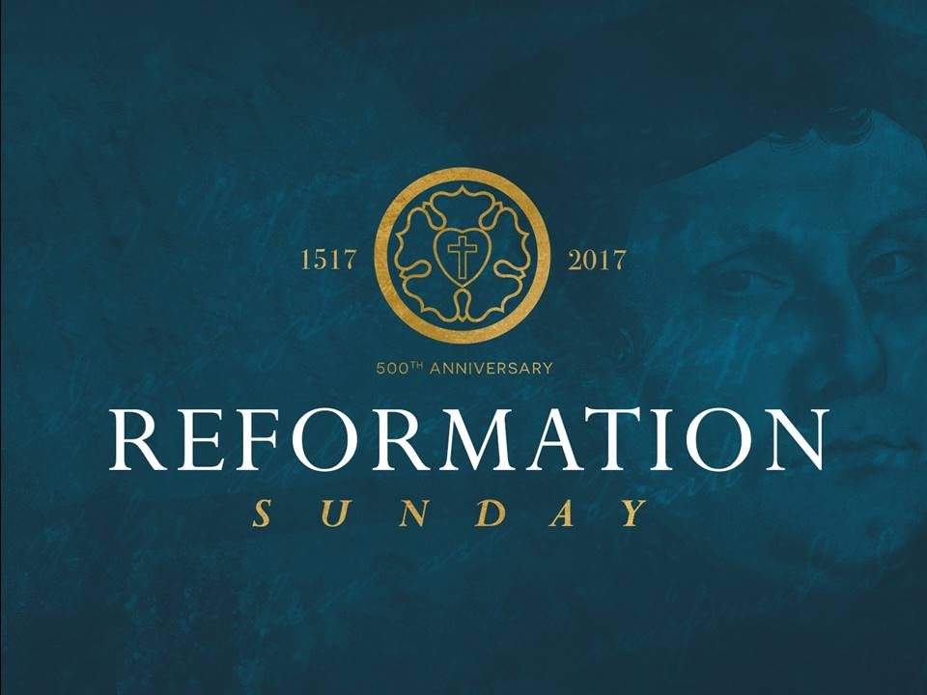
Ron & Jan Veltkamp will be volunteering with World Renew Disaster Response Services repairing homes in Rio Grande Valley, TX from October 25 – November 18 due to flooding in May and October, 2015. Please support them as a congregation with your prayers while they are on this assignment. Pray for safety, good health, a meaningful experience with opportunities to touch and give hope to hurting people in this relief ministry. We encourage you to write a note to them while they are on site. Their address is:

World Renew – DRS Volunteer
Attn: Ron & Jan Veltkamp
First United Methodist Church of Weslaco
520 South Illinois
Weslaco, TX 78596

This Week at Trinity

Sunday | 11:00 a.m. | Worship Service
 | 6:30 p.m. | Prayer Service
Tuesday | 7:00 p.m. | Coffee Break
Wednesday | 9:30 a.m. | Coffee Break / Story Hour
Thursday | 6:15 p.m. | AWANA
Next Sunday | 9:30 a.m. | Sunday School
 | This Week | Next Week
Greeters: | Sam & Phyllis Bowman | D & D Hopewell
Nursery: | Rose Kuiper & Megan DeVries | April Kuiper & Ellen Lechtenberger
Children’s church: | Kate Hopewell | Erin Vander Lugt
Coffee Clean-Up | Cox | Luncheon
Accompanist: | Jan DeYong | Kristi Kleaver
Sound: | Dave Hopewell
Offerings: | Downtown Soup Kitchen | Church Offerings

Committees and programs  Contact people  Building & Grounds Bob Groeneweg  Church Admin Assistant Kate Hopewell  Coffee Break Joy Sharpe  Outreach/Missions Gayle Cederberg  Fellowship Ron & Jan Veltkamp  Intercession Jon Sharpe  Library Mandi Dykstra  Prayer Network Pastor Bill  Sunday School Sup’t Kristine Adams  Women's Fellowship Denise Hopewell  Worship Committee Joy Sharpe  Trinity CRC Council: | Church Meeting Schedule  Sunday  Sunday School (Sept. - May) 9:30 a.m.  Morning Worship 11:00 a.m.  Evening Prayer Service 6:30 p.m.  Tuesday (Sept - April)  Coffee Break 7:00 p.m.  Council (2nd Tue. of month) 7:00 p.m.  Wednesday (Sept-April)  Coffee Break/Story Hour 9:30 a.m.  Thursday  AWANA (Sept- March) 6:15 p.m.  Church Office and Pastor's Hours:  9 a.m. - 12 p.m. Tues. through Thurs.
  Elders  Joel Adams ‘17  Jasper Hall ‘18  Keith Van Dyken ‘19 | Deacons:  Dave Cox ‘17  Terry Dykstra ‘18  Dave Hopewell ‘19

Announcements

The congregational meeting to vote on those qualified to hold office and to review the proposed budget will be held after the morning service today. Nominated for Elder; Ron Veltkamp, Mike Lindeen and for Deacon; Jan De Yong, Brett Kuiper, and Charlotte Long. The casting of the lot for elder and deacon will take place after the morning service on November 5.
Copies of the proposed budget have been placed in the folders. Please review before the congregational meeting today.
Today’s offering will be for the Downtown Soup Kitchen.
All undesignated gifts will go to this ministry.
There will be a luncheon next Sunday after the service.
Please bring your favorite dish to share.
Daylight Saving Time ends next Sunday,
so be sure to set you clocks back an hour.

Thanksgiving Blessing: Every Thanksgiving the Anchorage communities come together through the leadership of the Food Bank of Alaska to make sure that families in need can celebrate the holiday with a complete Thanksgiving meal. Churches play an important role in gathering a lot of the ingredients and helping families through the process on distribution day. They are expecting 3000+ participants this year. CAN YOU HELP? Let’s create a huge pyramid of canned corn! Trinity will collect canned corn. The Seventh Day Adventist Church will be joining in this effort. Trinity can make a real difference—let’s joyfully share with our neighbors this Thanksgiving!
Sacred Concert: Next Sunday Luther’s Musical Legacy Part 6: Music from Other Reform Movements will be airing from 6-9 a.m. on KLEF 98.1 FM

Ron & Jan Veltkamp will be volunteering with World Renew Disaster Response Services repairing homes in Rio Grande Valley, TX from October 25 – November 18 due to flooding in May and October, 2015. Please support them as a congregation with your prayers while they are on this assignment. Pray for safety, good health, a meaningful experience with opportunities to touch and give hope to hurting people in this relief ministry. We encourage you to write a note to them while they are on site. Their address is:

World Renew – DRS Volunteer
Attn: Ron & Jan Veltkamp
First United Methodist Church of Weslaco
520 South Illinois
Weslaco, TX 78596

This Week at Trinity

Sunday | 11:00 a.m. | Worship Service
 | 6:30 p.m. | Prayer Service
Tuesday | 7:00 p.m. | Coffee Break
Wednesday | 9:30 a.m. | Coffee Break / Story Hour
Thursday | 6:15 p.m. | AWANA
Next Sunday | 9:30 a.m. | Sunday School
 | This Week | Next Week
Greeters: | Sam & Phyllis Bowman | D & D Hopewell
Nursery: | Rose Kuiper & Megan DeVries | April Kuiper & Ellen Lechtenberger
Children’s church: | Kate Hopewell | Erin Vander Lugt
Coffee Clean-Up | Cox | Luncheon
Accompanist: | Jan DeYong | Kristi Kleaver
Sound: | Dave Hopewell
Offerings: | Downtown Soup Kitchen | Church Offerings

Committees and programs  Contact people  Building & Grounds Bob Groeneweg  Church Admin Assistant Kate Hopewell  Coffee Break Joy Sharpe  Outreach/Missions Gayle Cederberg  Fellowship Ron & Jan Veltkamp  Intercession Jon Sharpe  Library Mandi Dykstra  Prayer Network Pastor Bill  Sunday School Sup’t Kristine Adams  Women's Fellowship Denise Hopewell  Worship Committee Joy Sharpe  Trinity CRC Council: | Church Meeting Schedule  Sunday  Sunday School (Sept. - May) 9:30 a.m.  Morning Worship 11:00 a.m.  Evening Prayer Service 6:30 p.m.  Tuesday (Sept - April)  Coffee Break 7:00 p.m.  Council (2nd Tue. of month) 7:00 p.m.  Wednesday (Sept-April)  Coffee Break/Story Hour 9:30 a.m.  Thursday  AWANA (Sept- March) 6:15 p.m.  Church Office and Pastor's Hours:  9 a.m. - 12 p.m. Tues. through Thurs.
  Elders  Joel Adams ‘17  Jasper Hall ‘18  Keith Van Dyken ‘19 | Deacons:  Dave Cox ‘17  Terry Dykstra ‘18  Dave Hopewell ‘19

