Trinity Christian Reformed Church
3000 East 16th Ave., Anchorage, AK 99508
Office phone: 907-272-8431 E-mail: office@trinitycrcalaska.com
Pastor Bill Vis phone: 907-279-0278 Cell: 907-575-0514
E-mail: billvis1@gmail.com On the Web: www.trinitycrcalaska.com
WORSHIP SERVICE
September 24, 2017 - 11:00 a.m.
APPROACHING TO WORSHIP
Instrumental Prelude: Kristi Kleaver
Welcome and Announcements
* Songs of Praise: “Let This Be My Supreme Desire” Red #729:1-4
“Jesus Loves Me” Red #709:1-3
* Opening Prayer
“Will You Come and Follow Me” Red #742:1-5
SERVICE OF PRAYER
Prayer Concerns and Congregational Prayer

SERVICE OF THE WORD
* Song of Preparation: “Listen, God Is Calling” Red #753:1-3
(Children ages 2-Grade 3 may go upstairs to Children’s Church)
Scripture: Philippians 1:21 Pew Bible Page(s): 1784
Message: First Things First
Prayer of Application

WITHDRAWING TO SERVE
Morning Offering and Offertory: Church Ministries
* Song of Response: “I Love to Tell the Story” Red #262:1-3
* God's Blessing
* Doxology: “O God, You Are My God” (2x) Red #743
Postlude
* If you are able, please stand
Songs printed and/or projected with permission by CCLI #293603

Guests, we are glad you are here. Please help us get to know you by filling in an information card and dropping it in the offering plate. We will not contact you without your request.

Announcements

Next Sunday will be an autumn luncheon after the morning worship service. Please plan to join us! Lots of fresh veggies available or bring your favorite hot dish. There will a cake to honor Erik and Nicole (De Yong) Hjelm on their recent marriage. Cards and monetary gifts will be welcome for Erik and Nicole


Apples
pUmpkins
poTatoes
sqUash
toMatoes
zucchiNi

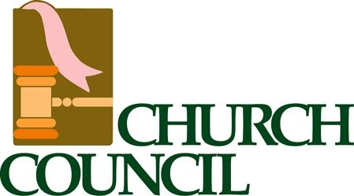

- Council reviewed the building inspection on the new parsonage. No major issues were found.

- Council began the process of soliciting nominees for council.

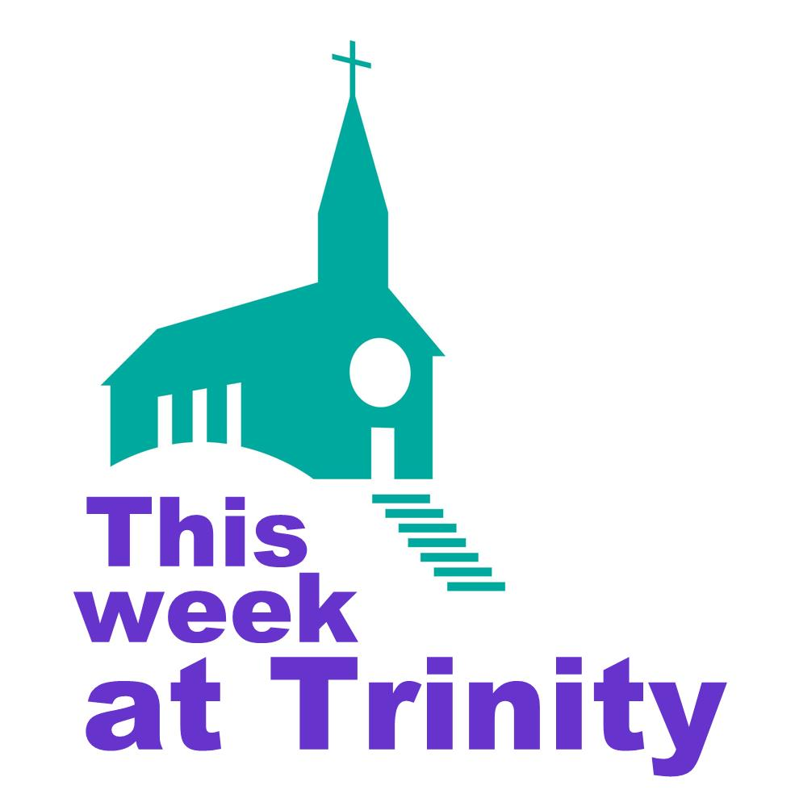
Sunday | 11:00 a.m. | Worship Service
 | 6:30 p.m. | Prayer Service
Tuesday | 7:00 p.m. | Coffee Break
Wednesday | 9:30 a.m. | Coffee Break / Story Hour
Thursday | 6:15 p.m. | AWANA
Next Sunday | 9:30 a.m. | Sunday School
 | This Week | Next Week
Greeters: | Jon & Joy Sharpe | Sam & Phyllis Bowman
Nursery: | Jan Henning & Charlie Beltran | Gabe DeVries & Brett Kuiper
Children’s church: | Phyllis Bowman | Erin Vander Lugt
Coffee Clean-Up | Halls | Luncheon
Accompanist: | Kristi Kleaver | Jan DeYong
Sound: | Dave Hopewell & Jeremy DeVries
Offerings: | Church Ministries | Church Ministries

Committees and programs  Contact people  Building & Grounds Bob Groeneweg  Church Admin Assistant Kate Hopewell  Coffee Break Joy Sharpe  Outreach/Missions Gayle Cederberg  Fellowship Ron & Jan Veltkamp  Intercession Jon Sharpe  Library Mandi Dykstra  Prayer Network Pastor Bill  Sunday School Sup’t Kristine Adams  Women's Fellowship Denise Hopewell  Worship Committee Joy Sharpe  Trinity CRC Council: | Church Meeting Schedule  Sunday  Sunday School (Sept. - May) 9:30 a.m.  Morning Worship 11:00 a.m.  Evening Worship 6:00 p.m.  Tuesday (Sept - April)  Coffee Break 7:00 p.m.  Council (2nd Tue. of month) 7:00 p.m.  Wednesday (Sept-April)  Coffee Break/Story Hour 9:30 a.m.  Thursday  AWANA (Sept- March) 6:15 p.m.  Church Office and Pastor's Hours:  9 a.m. - 12 p.m. Tues. through Thurs.
  Elders  Joel Adams ‘17  Jasper Hall ‘18  Keith Van Dyken ‘19 | Deacons:  Dave Cox ‘17  Terry Dykstra ‘18  Dave Hopewell ‘19



September 24, 2017



