Trinity Christian Reformed Church
3000 East 16th Ave., Anchorage, AK 99508
Office phone: 907-272-8431 E-mail: office@trinitycrcalaska.com
Pastor Bill Vis phone: 907-279-0278 Cell: 907-575-0514
E-mail: billvis1@gmail.com On the Web: www.trinitycrcalaska.com
WORSHIP SERVICE – March 25, 2018 - 11:00 a.m.
APPROACHING TO WORSHIP
Instrumental Prelude: Kristi Kleaver
Welcome and Announcements
Trio: “Hail and Hosanna”
Children’s processional: “Ho-Ho-Ho-Hosanna” (congregation joins second time through)
Opening Prayer
DECLARING OUR FAITH
* Song of Praise: “Alleluia! Alleluia! Hearts to Heaven” Red #179:1,4
Litany based on Psalm 118:19-29
One: Open for me the gates of Righteousness;
I will enter and give thanks to the Lord.
All: This is the gate of the Lord
Through which the righteousness may enter.
One: I will give you thanks, for you answer me;
You have become my salvation.
All: Hail Hosanna! Blest is he who comes in God’s
Own name to make our world God’s home!
One: The Stone the builders rejected
Has become the cornerstone;
The Lord has done this,
And it is marvelous in our eyes.
All: the Lord has done it this very day;
Let us rejoice today and be glad.
One: Lord, save us!
Lord, grant success!
Blessed is he who comes
in the name of the Lord.
From the house of the Lord we bless you.
All: Hail Hosanna! Blest is he who comes in God’s
Own name to make our world God’s home!
One: The Lord is God,
And he has made his light shine on us.
With boughs in hand,
Join in the festal procession
Up to the horns of the alter.
All: You are my God and I will Praise you;
You are my God and I will exalt you.
One: Give thanks to the Lord for He is good;
His love endures forever.
* Song of Response: “All Glory, Laud, and Honor” Red #146:1-5
SERVICE OF PRAYER
Prayer Concerns and Congregational Prayer
SERVICE OF THE WORD AND SACRAMENT
Stump the Pastor
* Song of Preparation: “Lift up the Gates Eternal” Red #144:4-7
(Children ages 2-Grade 3 may go upstairs to Children’s Church)
Scripture: Revelation 7:9-17 Pew Bible Page(s): 1874-75
Message: The Second Triumphal Entry
Prayer of Application
WITHDRAWING TO SERVE
Morning Offering: Church Ministries
Offertory: “The Holy City” Phyllis Bowman
* God's Blessing
* Doxology: “Lift up the Gates Eternal” Red #144:1-3
Postlude
* If you are able, please stand
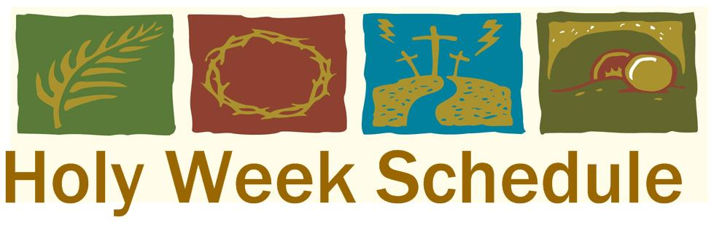
Songs printed and/or projected with permission by CCLI #293603
Announcements

Easter Brunch Food Needed:10 to 12 Breakfast Casseroles Maundy Thursday Service:
Sign up on the Bulletin Board 8 dishes of fresh fruit March 29 at 7:00pm.
1 dozen each: Muffins/cinnamon rolls/rolls Easter Sunday Breakfast:
Sacred Concert: Next Sunday An Easter Celebration April 1 at 09:45 Please join us!
will be airing from 6-9 a.m. on KLEF 98.1FM. Easter Sunday Worship Service: 11:00am

Practical Positive Parenting, held at Grandview Baptist, needs 3 volunteers for each evening, April 2 and May 3, to prepare set up and serve dinner. Contact Jan Henning at 350-3431 to help.

This week at Trinity Church

Sunday | 9:30 a.m. | Sunday School
 | 11:00 a.m. | Worship Service
 | 3:00 p.m. to 5:30 p.m. | Trinity Youth Group
 | 6:30 p.m. | Prayer Service
Tuesday | 7:00 p.m. | Coffee Break
Wednesday | 9:30 a.m. | Coffee Break, Story Hour
Saturday | 10:30a.m. | Choir
 | This Week | Next Week
Greeters: | Annette Compton | The Cox Family
Nursery: | Erin VanderLugt & Kristine Adams | Rose Kuiper & Megan DeVries
Children’s church:
Coffee Clean-Up | Jan De Yong
Accompanist: | Kristi Kleaver | Kristi Kleaver & Jan De Yong
Sound: | Ron Lindemulder | Jeremy DeVries
Offerings: | Church Ministries | Church Ministries
Prayer Service | The Veltkamps | No Prayer Service




Come and help Ahleen celebrate 100 years of God’s blessings! Cards are welcome;
Open House for
Ahleen Heynen’s
100th Birthday
Thursday, March 29, 2018
3PM to 6PM
Trinity Christian Reformed Church
3000 E. 16th Avenue, Anchorage, AK 99508
no gifts please. If you are unable to attend,
you may send Ahleen a card at 2020 Muldoon Road, #203, Anchorage, AK 99504.

for more information contact: Nancy Heynen @ (907)242-5556
March 25, 2018


