Trinity Christian Reformed Church
3000 East 16th Ave., Anchorage, AK 99508
Office phone: 907-272-8431 E-mail: office@trinitycrcalaska.com
On the Web: www.trinitycrcalaska.com
WORSHIP SERVICE
June 10, 2018 - 11:00 a.m.
APPROACHING TO WORSHIP
Instrumental Prelude Jan Veltkamp
Welcome and Announcements
* Songs of Praise: “My Life Flows on in Endless Song” Red #443
“Lift High the Cross” Red #264: vs1,2,4,6
* Opening Prayer
“I Sought the Lord, and Afterward I Knew” Red #685
DECLARING OUR FAITH
I believe in God, the Father almighty,
creator of heaven and earth
I believe in Jesus Christ, his only Son, our Lord,
who was conceived by the Holy Spirit
and born of the virgin Mary.
He suffered under Pontius Pilate,
was crucified, died, and was buried;
he descended to hell.
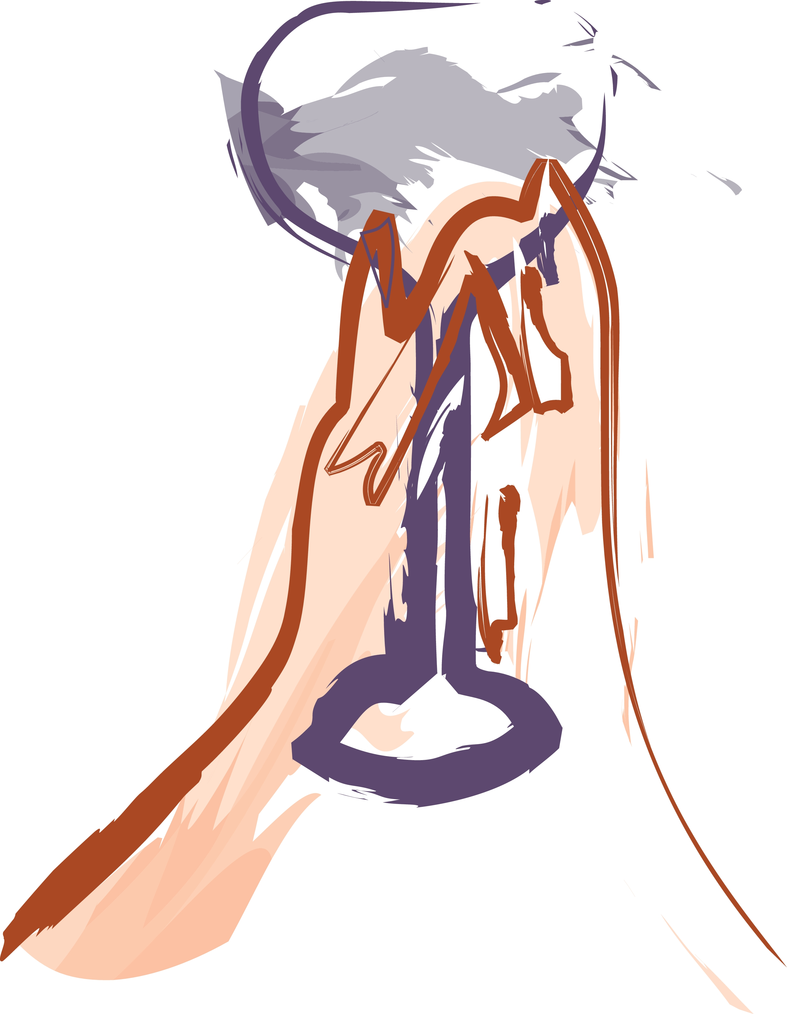
The third day he rose again from the dead.
He ascended to heaven
and is seated at the right hand of God the Father almighty.
From there he will come to judge the living and the dead.
I believe in the Holy Spirit,
the holy catholic* church,
the communion of saints,
the forgiveness of sins,
the resurrection of the body,
and the life everlasting. Amen.
(* that is, the true Christian church of all times and all places)
Song of Response: “My Tribute” Solo Verses: April Kuiper
Congregation joins on the refrain (To God be the Glory)
Grey #632
SERVICE OF PRAYER
Prayer Concerns and Congregational Prayer
SERVICE OF THE WORD
* Song of Preparation: “We are People on a Journey” Red #142
Scripture: Acts 9:1-9 Pew Bible Page: 1670
Message: God’s Sovereign Call of Paul Pastor Bernie Van Ee
Prayer of Application
WITHDRAWING TO SERVE
Morning Offering: Church Ministries, as we sing:
Song of Response: “Jesus Calls Us o’er the Tumult” Red #121
* God's Blessing
Doxology: “The Lord Bless You and Keep You” Solo: April Kuiper
Postlude
* If you are able, please stand
Songs printed and/or projected with permission by CCLI #293603

Announcements
The Hulst Family are on their way to Anchorage!
Check the map by the elevator to follow their journey.


A Memorial Service for Lorenz Carlson is scheduled for Friday June 22 at 1 p.m.
Please come and celebrate his life.

The council will meet on Thursday June 14. If you have items for their consideration please contact a member of the council (listed on back).

Sunday June 24, Please mark your calendars for the Installation of Ben Hulst as pastor at Trinity CRC. The Lords supper will be served and we will celebrate after the service with a potluck of local food. AK has an abundance of resources, let’s share, let’s eat!

Sacred Concert: Next Sunday Psalm Settings through the Centuries will be airing from 6-9 a.m. on KLEF 98.1 FM

The meals that members provide to Ahleen Heynen are a precious ministry. There is a new sign-up sheet on the bulletin board for anyone interested in becoming a part of this ministry.

This week at Trinity Church
Sunday | 11:00 a.m. | Worship Service
 | 6:30 p.m. | Prayer service
 | This Week | Next Week
Greeters: | The Bowmans | The Bowmans
Nursery: | Charlotte & Mark Long | Jan Henning & Charlie Beltran
Coffee Clean-Up
Accompanist: | Jan Veltkamp | Kristi Kleaver
Sound:
Offerings: | Church Missions | Church Missions
Prayer Service | Jon Sharpe | Joy Sharpe

Committees and Programs  Contact People  Building & Grounds Bob Groeneweg  Church Admin Assistant Brett Kuiper  Coffee Break Joy Sharpe  Outreach/Missions Gayle Cederberg  Fellowship Ron & Jan Veltkamp  Intercession Jon Sharpe  Library Mandi Dykstra  Prayer Network Pastor Bill  Sunday School Sup’t  Women's Fellowship Denise Hopewell  Worship Committee Joy Sharpe  Trinity CRC Council: | Church Meeting Schedule  Sunday  Sunday School (Sept. - May) 9:30 a.m.  Morning Worship 11:00 a.m.  Youth Group………………………3:00 p.m.  Evening Prayer Service 6:30 p.m.  Tuesday (Sept - April)  Coffee Break 7:00 p.m.  Council (2nd Thurs. of month) 7:00 p.m.  Wednesday (Sept-April)  Coffee Break/Story Hour 9:30 a.m.  Thursday  AWANA (Sept- Nov. Jan.-Mar.)...6:15 p.m.  Church Office and Pastor's Hours:  Tuesday through Thursday 9 a.m. - 12 p.m.
  Elders  Jasper Hall ‘18  Keith Van Dyken ‘19  Ron Veltkamp ‘20 | Deacons:  Terry Dykstra ‘18  Dave Hopewell ‘19  Jan DeYong ‘20



Trinity Christian Reformed Church
3000 East 16th Ave., Anchorage, AK 99508
Office phone: 907-272-8431 E-mail: office@trinitycrcalaska.com
On the Web: www.trinitycrcalaska.com

June 10, 2018

